# **User Guidelines for Covid-19 Dashboard**

1. Users can visit the Covid-19 Dashboard by visiting the <https://datastudio.google.com/embed/reporting/7c613f6a-74e3-48de-afb0-1ae1d9a68302/page/doJLC> link or by entering it manually on the browsers address bar.



Figure 1. Dashboard URL

1. After entering on browsers address bar user will be redirected to the homepage of Covid-19 Dashboard.

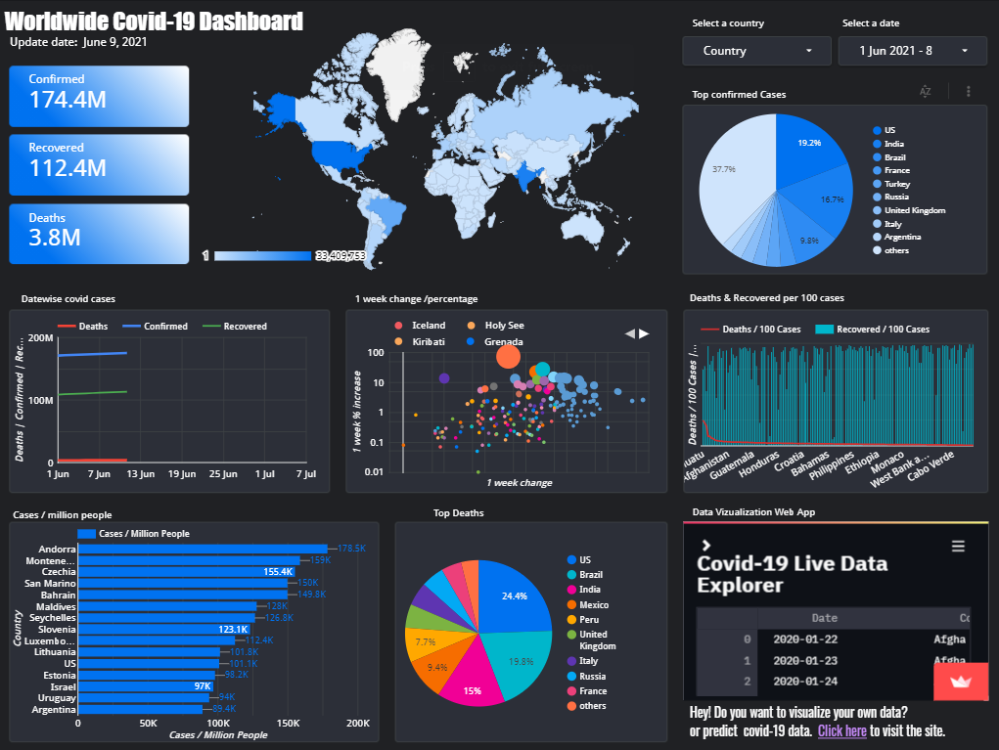

Figure 2.Homepage of the dashboard

1. This section updates when there is an increase or decrease in the total number of cases worldwide or per selected country. The first scorecard covers total confirmed cases, the second covers recovered cases and the third contains death cases.

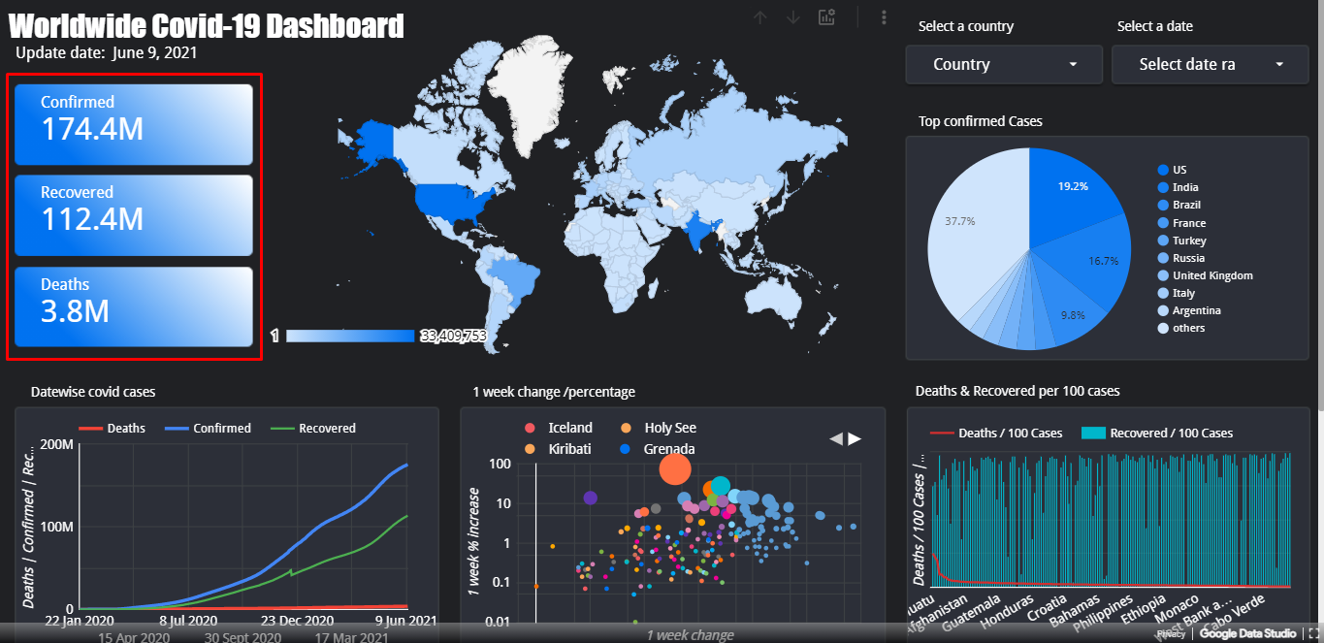

Figure 3. Confirmed, recovered, and death cases

1. Users can select a specific country or multiple countries to visualize the data. As per the user's input, all the graphical components change their data.

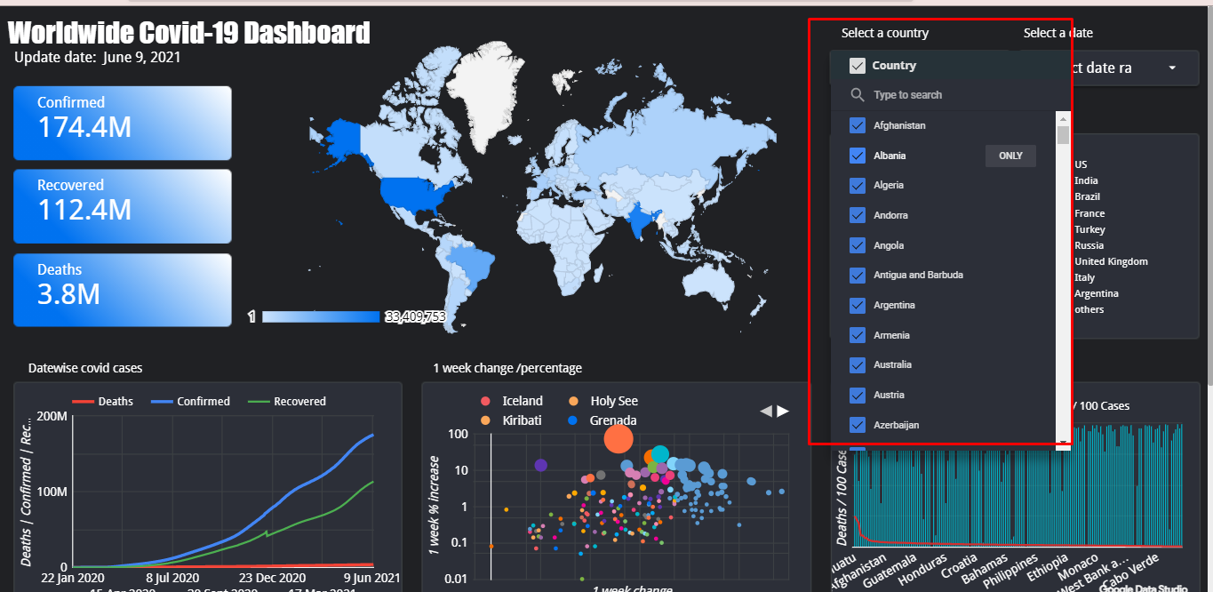

Figure 4. Select country

1. Whenever users select a specific country all graph and charts changes as pes user inputs as shown in figure(See figure 5). As we have selected India, Nepal, and the US it only provides the data of these countries.

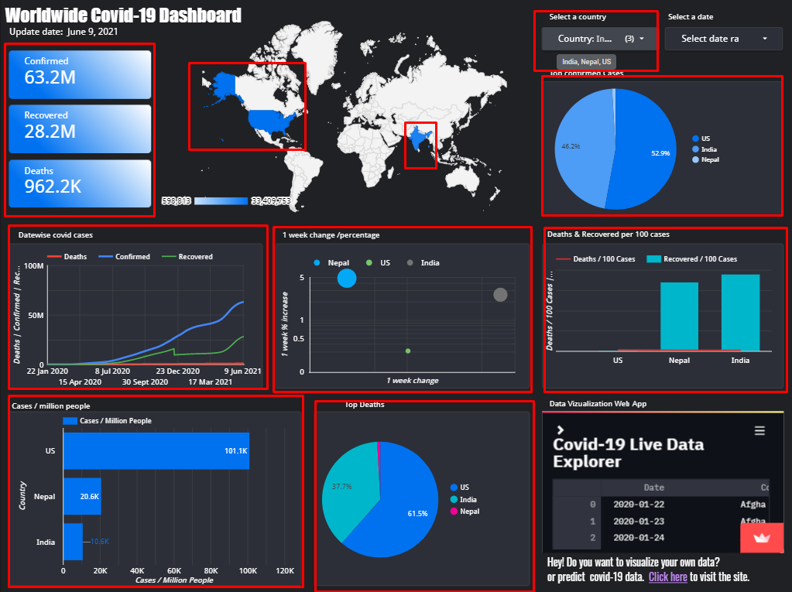

Figure 5. Country output

1. Users can select a specific date for which all graphical component tries to display the data of the selected date only.

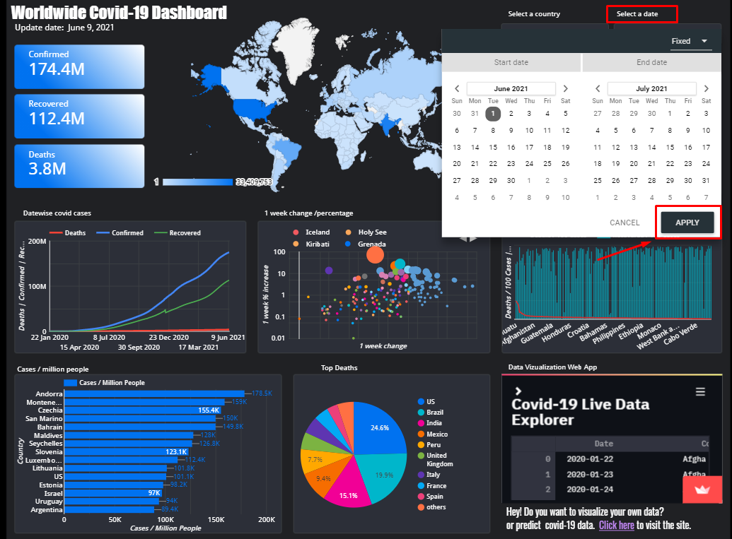

Figure 6. Select date

1. Whenever a user selects a date the graphical components and their data or value change as shown in figure

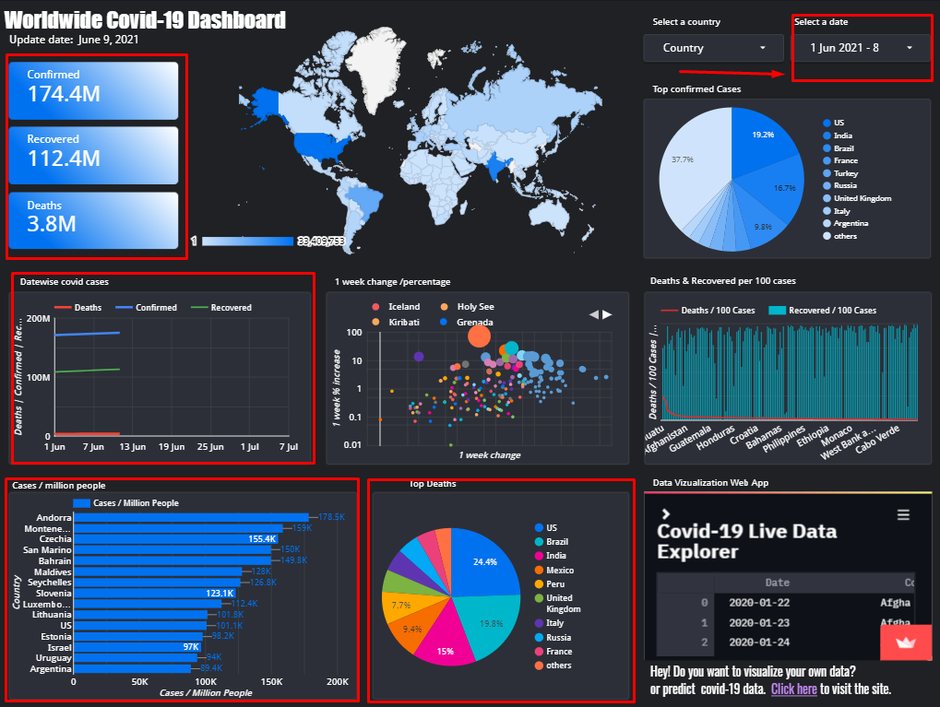

Figure 7. Date output

1. Users can download or export data of graphical components in various file formats as shown in the figure( see figure 7).

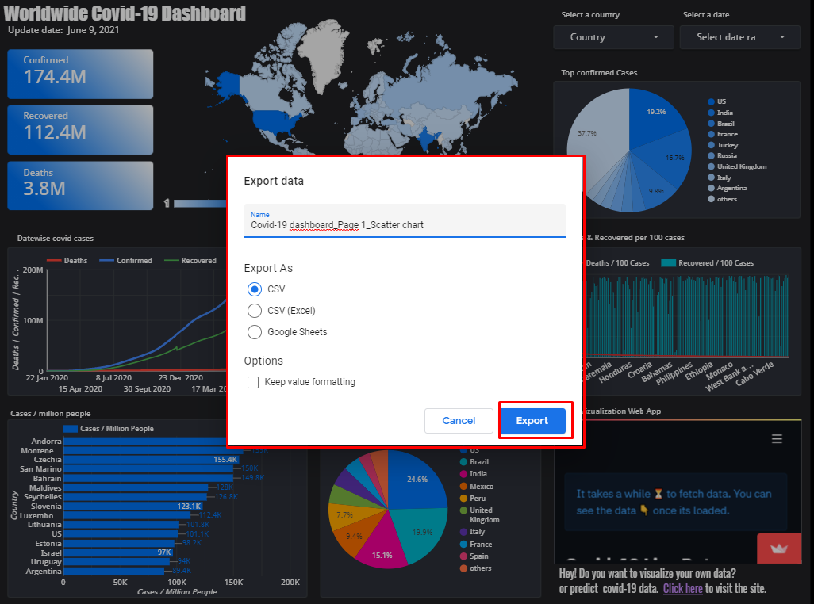

Figure 8. Export data

1. Users can redirect to the data visualization web app by clicking on the link ‘Click here’ under the dashboard. A graphical representation is shown for the web app. User can take a peak at the app and can visit the web app by clicking on it(see figure 7).

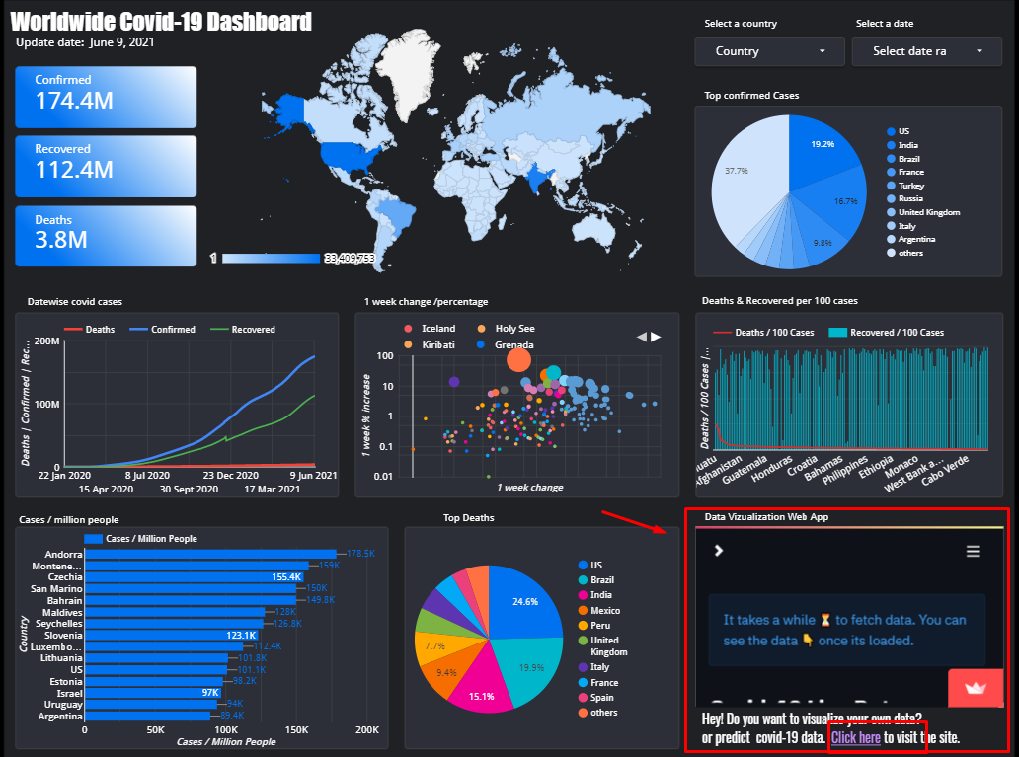

Figure 9. Link for the web app